Name: Benjamin Mendham Williamson
Candidate Number: 7927
Centre Number: 37490
Centre Name: Greenhead College
Computer Science NEA OCR H446/03 Computer Science A Level
Inventory Management System
Contents
Analysis 2
Identification of Problem 2
Research Problem 3
Stake Holders 4
Essential features 5
Limitations 5
Requirements 5
Success criteria 5
Design 5
Decomposition 5
Structure 5
Algorithms 5
Variables/Data structures 5
Features 5
Test Data 5
Iterative 5
Post development 5
Development 5
Post Development 5
Testing 5
Success Criteria 5
Final Product 5
Limitations 5
Maintenance 5

Analysis

Identification of Problem
During the COVID-19 pandemic, the need for online shopping became a necessity. Companies like Amazon and Ocado made massive profits as people started to use their services as many other companies struggled to move to the online world. One of the largest parts of online shopping operations is warehouse and inventory management. Many businesses already had An Inventory management system in place however most designed for local small-scale sale rather than the large-scale online world. Another thing that became a lot more necessary was postal and delivery services, these services will often include large depots and storage facilities as the goods are being transported. 1 in 10 packages are lost every day many of this due to being lost in the large warehouses and depots used by these companies.
Having a well organised inventory is necessary for any Business to survive especially in the online era. Many businesses have used Pen and Paper management in the past however this is unreliable requiring the user to have neat handwriting and layout. It also meant that people had to update every copy of the stock sheet if used between multiple users. It also becomes useless for large scale operations as the necessary amount of paper becomes unmanageable and a management system becomes needed for organising the management system. An Inventory Management application becomes the obvious choice in the modern technological era to keep track of what things are in your inventory and, for larger operations, where things are kept.
An inventory management system is suitable to be made computationally due to using many computational methods such as: Abstraction, abstraction is the removal of unnecessary detail to make programming easier and the user interactions cleaner and intuitive to use. It will be used here as you are removing information like what the item looks like or not keeping track of specific items and just grouping all similar items under one category, by grouping similar items and not having images of each item you will drastically reduce the memory needed to run it plus the storage needed to store all the data. This means that It can run on smaller and weaker systems, this is absolutely critical as many devices in use by companies that would need this system are older and cheaper to save costs, this means the application needs to be able to run on weak systems running old OS’s like Windows 7 or Vista; Decomposition, decomposition is the breaking apart of a solution to make it easier to solve. It can and should be used as there are lots of separate systems in one application, there will be an adding and removing system, an info accessing system with searching and sorting systems within it and in later versions, a warehouse location system. It’s essential to do this as it speeds up development of the program and more importantly reduces the size and processing power of the application meaning it can run on the lightweight systems this application will be run on; Logic, logical thinking is the backbone of all computational methods and computers in general. It is the use of logic gates and branching to acquire the desired effect. It will be used here to select which part of the programming is used the addition and removal of items, and in the use of the many algorithms used throughout like the searching and sorting algorithms used in the data accessing part if the program or the pathfinding algorithm that will be used in the warehouse location system; Thinking Ahead, thinking ahead is the preparing for the future and preparing for the addition of new systems within the program, this will be used with an Object orientated approach to reduce the amount of programming done. By making it easier to program new things and add new things into the program. Allowing for quicker updates and bug fixing as things are contained within in classes. This allows for a nicer experience for the user and better upkeep for the program and more compatibility across OS’s; Visualisation, visualisation is the use of visual images and diagrams to help people understand and use a piece of software. This application will use Visualisation the form of tables showing ordered lists of available items, or a visualisation of the graph used to represent the warehouse in the warehouse location system.

Research Problem
Zoho inventory is an inventory management system that shares similar features that I would like to include in my program. The two features that it shares Inventory control and warehouse management systems.
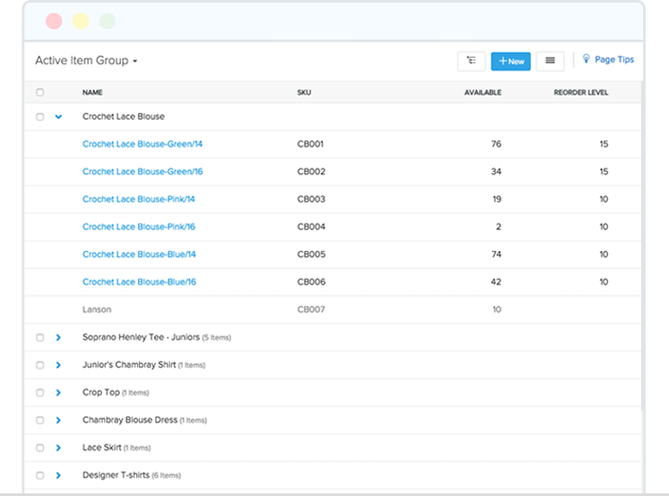
The inventory control has features like product listings, Automatic reordering, stock adjustments and expiry date tracking. The Product listings use sorting and searching algorithms to make it easy to find items in your inventory plus categories and sub-categories using classes and objects. I Will implement a searching and sorting algorithms into my software alongside a categorised GUI and class hierarchy.
The stock reordering feature is incredibly usefull esspecially for small buisnesses that don’t have time to check the stock of everything or large warehouses where having full stock is imperrative. I will try to add this feature my own program. It will require the use of web integration to access the websites to reorder stock from. The stock adjustments allows access to all the details of a specific item or category of items without putting the integrity of the system at risk. They have achieved this with buffers and encapsulation allowing only one fucntion to access data at a time and no direct access to object attributes only functions with specific saftey parameters in place. They also have an expiry date tracker this makes sure that perishable goods arent sold out of date and emphisise the sale of older products over new products. This uses a queue data structure of the items. I will try and implement a similar system into my program.
Zoho inventory also has a warehouse manegement system. This has some features I would like to try and implement into my software. It has the ability to manage multiple separate warhouse locations and all of the separate inventories but also still be able to manage the overall inventory. This is a vital system when dealing with warehouses as it allows the warehouse specfic managers to manage their warehouse how they want but also allow an overall management of the entire system. Another system used by Zoho is the ability to transfer specific items between warhouses. This is usefull to keep control over all the items and makes it easier to send and manage items across a wide geographial area. This uses objects and serial numbers to keep track of all the items. A vital part of the warehouse management system that Zoho has that I would like to implement across my entire program is analysis reports of separate warehouses and the whole inventory. This is an imperative system as reports allow for data analysis either by a hired data analyst or a separate program designed for data analysis. I will output this data in a form that is easily accessible by both humans and computers.

Stake Holders
My system has a variety of stakeholders: small business owners, company managers, warehouse managers and warehouse employees. Small business owners are people who own small business with little to no management system in place. They often have a small inventory with only one location and probably a small number of products. They will be able to use this software to manage what is in their inventory in a simple manner with the ability to have an organized list of their inventory without much setup with the features of controlling batches and item details with ease without having to bother with a full setup of warehouses and such. However, they can still have the ability to expand their system as much as they want at a later date. This allows for a small stress-free experience for small business owners that want to get started quickly but can expand their business at their own rate. This is a very useful for small business owners as they can start using the software quickly with an experience suited to their needs right after downloading with a simple easy to use system.
Company managers are people who own or manage large companies with one or more locations and large inventory. They will want to be able to access all of their inventory and keep track of everything across multiple locations whilst still being able to have location specific data and management. This software will be able to readily set up a large-scale warehouse management system. They will also be able to track specific items and batches as they travel between and in and out of the locations and have been able to control everything fully. Business managers will want to be able to for setup for access levels across the inventory to keep a level of security within the system. They will be able to set up automatic reorder which is useful to make sure stock is full in the multiple locations.
Warehouse managers are people whose job it is, is to manage the stock and inventory of a single warehouse. They will need to be able to track what’s coming in and out of their warehouse, know where things in the warehouse and be able to adjust stock as much as they need within their requirements. They won't need access to other warehouses. They will be able to do this with the item adjustment and stock listing features to adjust and keep track of the flow of items into and out of their warehouse. They will be able to be notified of adjustments to stock and items made by someone else as well. They will be able to find where items are in their warehouse and how full the warehouse is. These are very useful for warehouse managers as they are in charge of everything in the warehouse so need to be able to track everything int the warehouse.
Warehouse workers are people who work around a warehouse, they have to move and actually deal with the stock. They need to be able to know where things are in the warehouse and be able to work out the shortest route around a warehouse collecting the things they need. They need to be able to adjust stock levels as well. They will be able to all of this with the features in my program. The warehouse location system will be able to help locate and find the quickest route when collecting things with a useful and intuitive GUI. They will also be able to adjust the stock levels and only the stock levels with the access levels in place.

Essential features
Taking into account the research into other similar products on the market and my stake holder needs I have identified some essential features my program will need.
- It will need to be able to permanently store data about every item in the system
- The data needs to be safe and only accessible by certain people and access levels and therefore will need a login system
- It will need to be able to organise and search all the data in the system and display it in an intuitive and useful way
These are the bare minimum features for my program, I intend on adding more as I develop the program however these are the features that would solve the problem. The storage of data permanently is necessary for this solution as without permeant storage the application would need to be running at all times and all the data would be stored I memory rather than storage and therefore would slow the application to a halt on most If not all devices especially the low budget, old machines I am aiming to be able to run this program on. The data needs to be safe as the amount of stock and therefore what can be sold needs to be accurate or the business running the software can lose money due to errors or people accessing data, they shouldn’t be able to. The organisation and ability to search for data is necessary otherwise it becomes impossible to find things in large inventories. And not being able to do that defies the whole point of the solution.

Limitations
The solution will not include a POS system as this would take a long time to implement and wouldn’t be required for all stakeholders as some like the warehouse manager and worker only need to worry about what is in the warehouse not things being sold. However, it is understood that some people will want direct contact between a POS system and the inventory management system so a small API may be implemented so that a POS system can work directly with the inventory system if required.
The solution can’t be to complex, i.e. not using superfast sorting algorithms as this would require a higher spec machine to run on whereas it needs to able to run on weaker machines and therefore it is more favourable for a slightly slower sorting algorithm like quicksort that is lighter on the machine than a faster algorithm like radix that is more resource intensive and therefore the machine would struggle to run it for a small possible speed increase.

Requirements
I am going to be programming this an c# so the final application will just be an executable able to be run by any windows machine. I will be programming using the .NET 4.7 Framework which requires windows 7. This is a low enough spec OS that most systems that need my program will be running if not a higher spec OS like windows 8,10 or 11. My program will only be able to run on windows machines as it will be released as an .exe file, however this shouldn’t be a problem as most people use windows and it’s the cheapest and therefore most large companies use it. If running a large-scale operation, it may be viable to have the database set up on a large server rather than one machine however this won't be necessary if you are running it on one computer like a small business might. However, as they grow, they might want to invest in a dedicated hard drive to store the data on rather than a smaller SSD that is used for more everyday things.

Success criteria
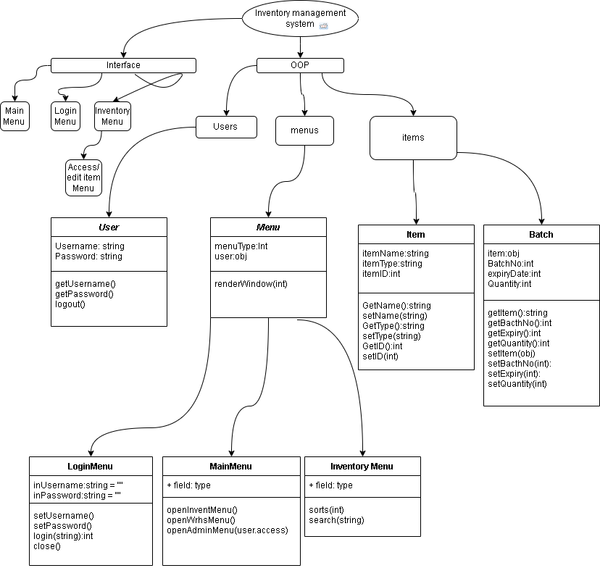
1.The software should have an easy to use user interface. This is a usability criteria and is required to make sure that the software can be used. A hard user interface can be scary to users and make them not want to use the software.
2. The software should have an interface that allows access to all functions of the program. This is a functionality critera that makes sure that all the features can be easily used and found and makes sure the sure interface is functional.
3. The software should have a login system with unique users. This is both a usability and functionality criteria as it means each user can have their own login and it is used to keep the software safe from unauthorised access. By having separate users we can also add access levels as an extra feature if we have the time/ resources to do it.
4. The software should have a main menu that allows for easy navigation around the program. This is a usability criteria as this makes sure that the user can find everything they need to do in one place. It is necessary to be able to find everything in one place as otherwise it can be quite daunting for the user.
5. the main menu should have easy ways of getting to the other sub menus in the program. this is a functionality criteria . This is needed to make sure that the the features of the program can be accessed with ease.
6. the software should have a menu that allows access to look at and edit all the items in software. This is a both a functionality and usability criteria as it allows the user to access their items as well as change and edit them where necessary. This makes sure the user has full control over the items in the system.
7. the inventory menu should have search and sort functions to help find items easier in it. This is a usability and functionality criteria. It makes finding items easier and is makes the product more user friendly
8. the software should have item objects that hold a variety of information about the item. This is a functionality criteria as it means that each item type can be found and searched for as well as kept in an organised fashion and keeping all the data safe without being edited through proper means.

Design

Decomposition
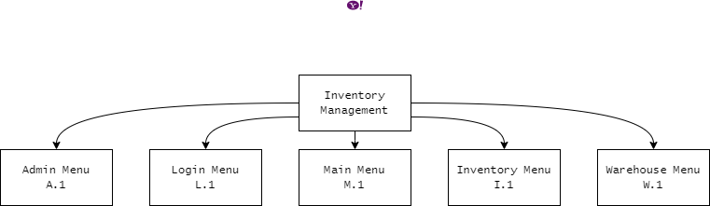
I have decomposed my software into these main modules. This is very important as it makes it easier to focus on each of these separate sections. Each of the menus is a module that needs to be developed, these separate sections for the most part won’t interact with each other and will be developed separate from each other by doing this it becomes easier to develop the modules as I can focus on one at a time with out having to worry about the other modules. It also means I can test and debug them separately which speeds the overall process up massively. By having them as separate modules I can edit and changed them with fear of the changes affecting the overall system. This is vital for the upkeep of the program as if in the future I or someone else needs to come back and update the software so that it works on newer operating systems it can be done with ease.
By having separate modules, I can program each module individually, this is useful as if I get a “block” for one of the modules I can move to a different one that has a different problem to solve. This means I can carry one working on the program with out getting burnt-out as quick. It can also make focusing on one area easier as you only need to think about in a much smaller context this can help you stop being overwhelmed by the number of things you have to do. It can stop you from panicking and help keep a calm and positive mindset which is vital to do a burn out can really stop the development of a program if it gets too bad.
The reason I have split into these modules is because I each is a menu with a specific purpose. The main menu is a simple menu designed to make it easy to navigate through the program. The login menu allows users to login into the software with that user’s specific permissions. The inventory menu will have functions to easily view and edit any item or group of items with the systems inventory. The warehouse menu will allow have feature that make managing the warehouse easier and simpler. And the admin menu will be a menu designed for the admin users only, and will have features an admin would need like a adding users or changing permissions.

Login Menu
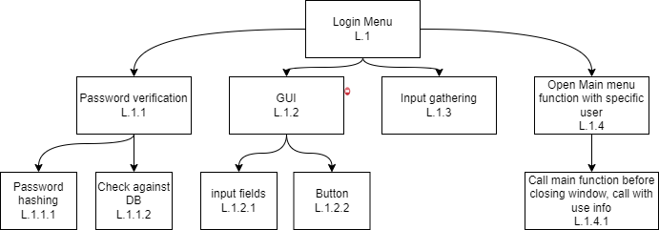
I have decomposed the login menu into these parts. It is important to decompose into these parts as it becomes much easier to understand and break up our development time on a specific module. It also helps when creating success criteria and test data.
One of the parts of this module is the password verification (L.1.1). I have decomposed this from the overall module as it’s a vital part of the login menu. It makes sure that the password and username match in the system and keeps the software safe. This section needs to have the most security as it keeps the entire system safe. It will have a hashing algorithm (L.1.1.1) to keep the stored passwords secure in case of a Database breach. All passwords will be stored in a secure Data base.
Another part of this module is the GUI(L.1.2), The GUI will be simple with 2 input fields(one for username and one for password) and a button to send the data to be checked. These are the only functional parts of the GUI as anymore would make it confusing for the user. The overall interface will be easy to use and simple to understand.
The Login menu will need to be able to get the information from the fields and pass it to be checked against the data base. I have decomposed this part of the module as it will help with security by having a function in between the GUI and the password verification you can stop potential attacks like SQL injections. This function will have input sanitisation to help with this.
The final part of this module I have decomposed is the calling of the main menu function with a user ID and then closing the login menu. I have decomposed this is this is a part of the program that means that the rest of the program can be run.

Main Menu

Structure

Algorithms

Variables/Data structures

Features

Test Data

Iterative
White Box Testing: This is in house testing done by the developer(ME!!) to test all the functions of each specific module. Each module will have its own test table for each round of testing. Any errors can be fixed quickly and simply without much fuss.
Test Number | Test Data | Data Type | Justification | Expected result | Actual result | Changes Made
1 |  | None
2 |  | Valid
3 |  | Erroneous
4 |  | Boundary

Black Box Testing: This is external testing done by the client

Post development

Development

Post Development

Testing

Success Criteria

Final Product

Limitations

Maintenance

(Weise, 2021)
(Biron, 2019)
(Zoho.com, n.d.)

